# Kioptrix Level 1 - Vulhub

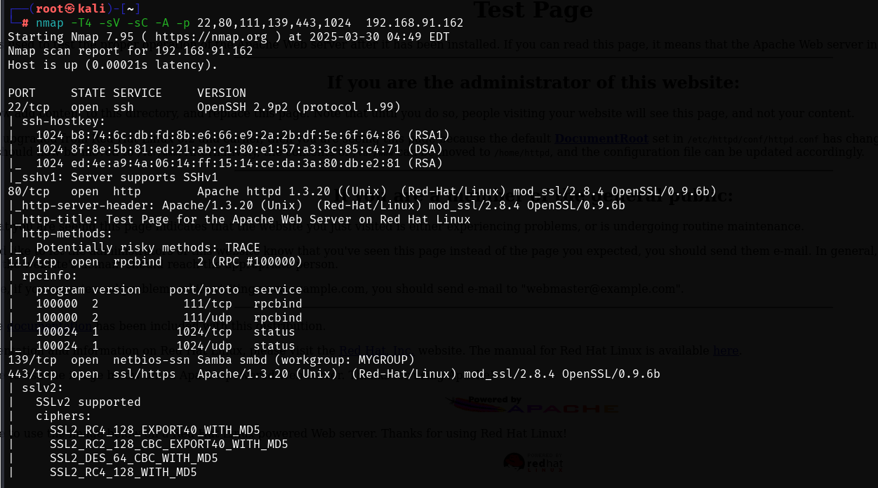

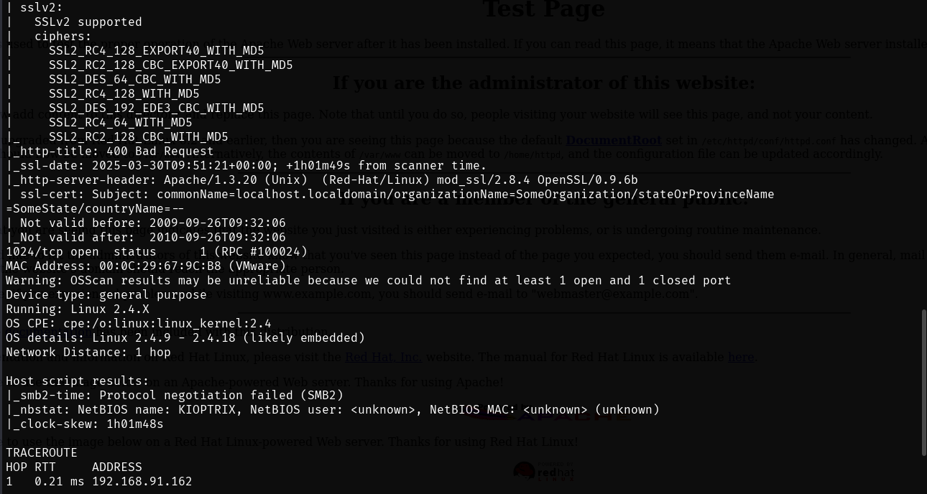

# INFORMATION GATHERING

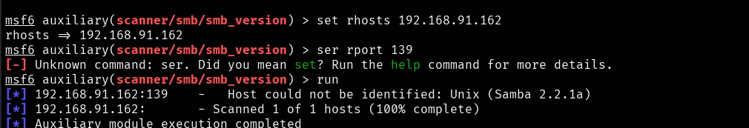

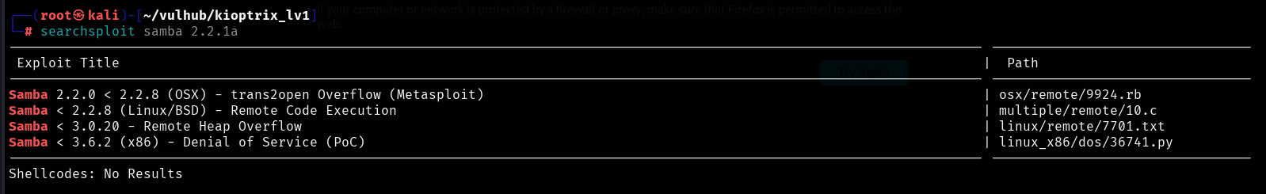

# EXPLOIT

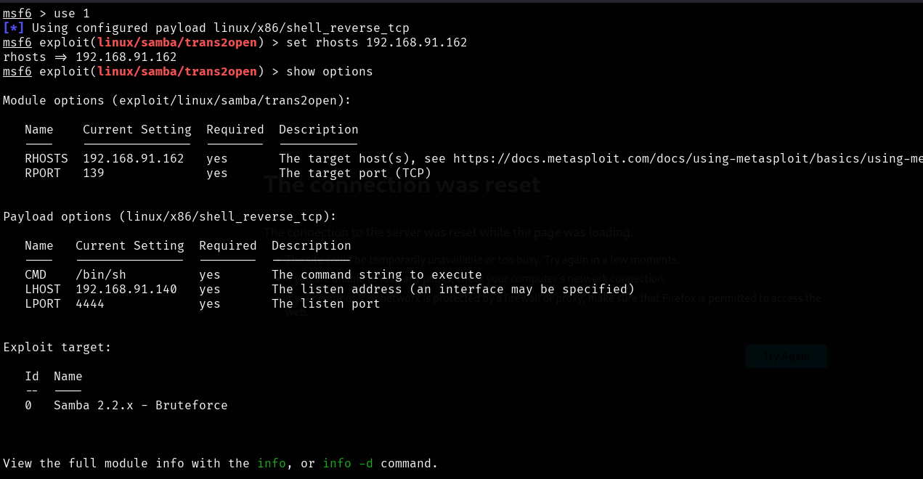

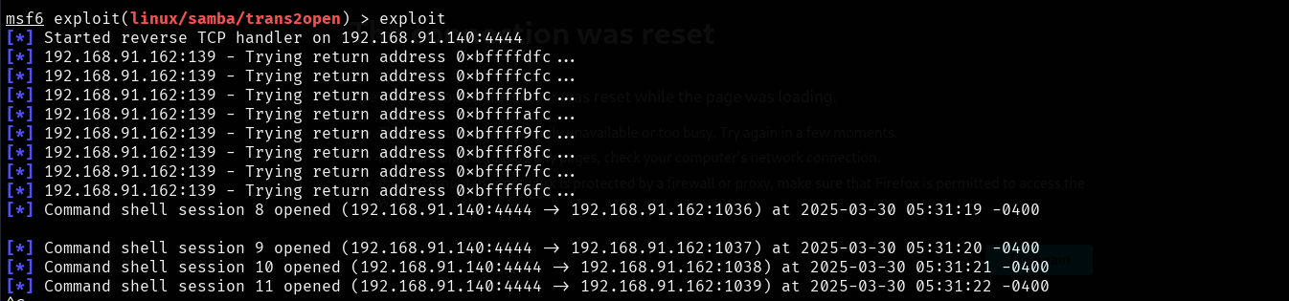

We are Root!

